This plan must be included with the online request.

- Indicate the street name and address.

- Locate the trees to be felled by moving the numbers corresponding to the trees indicated on the property.

- Indicate the species corresponding to the number of the tree to be felled by moving the species options listed below.

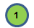
Fruit tree
Conifer
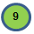
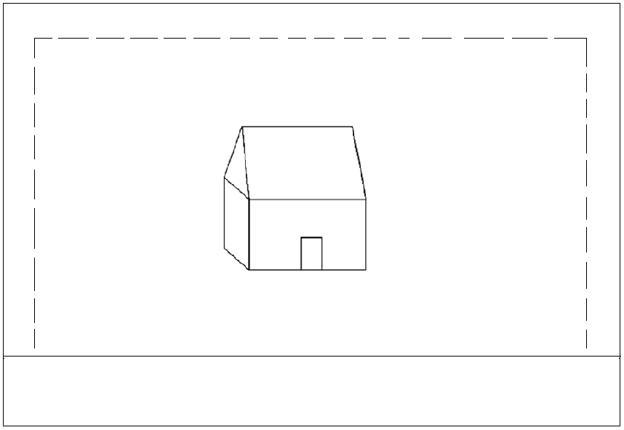
Pine
Fir
Spruce
Other
Birch
Property lines
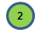
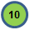
Elm
Linden
Ash
Crab apple
Willow
Maple
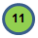
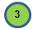
Oak

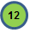
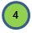
Honeylocust

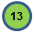
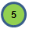
Unknown

#:

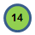
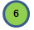

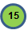
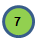

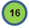
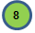

Street:

- Identify the tree(s) to be felled on your property using tape or any other object that allow us to clearly identify the tree (s) to be cut down.
(If needed, tape is available at the City Hall multiservice counter.)

